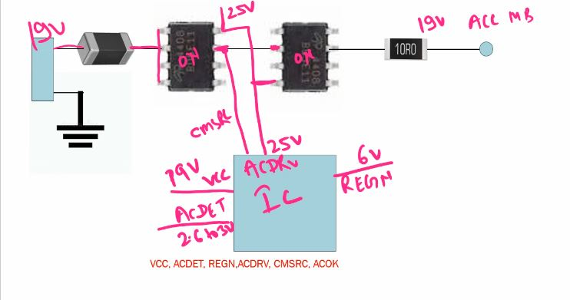
- VCC
- ACDET
- REGN 6V (ic internal work ok)
- ACDRV (to switch on mosfet)
- CMSRC – mosfet on feedback
- AC OK – sio feedback

